Al -FITTRACK

AI – AUGMENTED BACKEND DEVELOPMENT PROJECT

TEAM ID : SWTID-2026-6868

TEAM LEADER
1. KRITHIKA J-krithikajayakanthan@gmail.com

TEAM MEMBERS
2. KAVYA SRI K - ksri1106@gmail.com
3. KEERTHIKA S- keerthikasakthivel87@gmail.com
4 . MAGARASI E K - magarasiesakkiyappan@gmail.com
AI-Powered Fitness Tracking and Recommendation Backend
Project Type: AI-Augmented Backend Web Application
Technologies Used:
- Node.js
- Express.js
- MongoDB
- JavaScript
- JWT Authentication
- REST APIs
- Gemini AI Service
- Thunder Client
Development Environment: Visual Studio Code
Backend Port: 5000
PROJECT DESCRIPTION
Project Description
AI FitTrack is an AI-augmented backend web application developed to provide intelligent fitness tracking, personalized workout recommendations, and AI-generated fitness insights. The system is developed using Node.js, Express.js, MongoDB, and Artificial Intelligence services. It provides REST APIs through which users can register, log in, access their protected profile, submit fitness information, and receive AI-generated recommendations.
The application follows a structured backend architecture with authentication, database connectivity, controllers, routes, middleware, and AI service integration. JWT authentication is used to protect user-specific APIs, while MongoDB is used for storing user information. The system can also be extended in the future with advanced features such as semantic search, vector search, RAG, AI chatbot functionality, and role-based access control.
SCENARIO: PROBLEM IDENTIFICATION
Identify the Problem
Maintaining a consistent fitness routine can be challenging for many people. Users may know that exercise is important but may not know which exercises are appropriate for their fitness level, experience, or personal goals.
Traditional fitness applications often provide general workout information that may not be sufficiently personalized. A fixed workout plan may not consider whether a user is a beginner or experienced, or whether the user's objective is strength, endurance, weight management, or a specific fitness goal.
SCENARIO: NEED FOR AI
Need for Artificial Intelligence
Artificial Intelligence can improve fitness applications by making recommendations more personalized and responsive to individual requirements.
Instead of providing the same workout information to every user, an AI-enabled system can consider information such as:
- Age
- Fitness goal
- Experience level
- Workout frequency
- Workout duration
- Calories burned
Based on these inputs, AI can generate natural-language recommendations that are easier for users to understand.
For example, in AI FitTrack, a user can provide an age of 25, a fitness goal such as developing abdominal muscles, and no previous workout experience. The AI service can generate a beginner-oriented recommendation with suitable exercises and guidance.
Similarly, workout statistics can be provided to the Fitness Insights API so that the AI service can generate an explanation of the user's current workout activity.
PROPOSED SOLUTION AND IMPACT
Proposed Solution
AI FitTrack provides a backend solution that combines REST API development with Artificial Intelligence.
The system provides:
- User Registration
- User Login
- JWT Authentication
- Protected Profile API
- Fitness Insights API
- Workout Recommendation API
- MongoDB Database Connectivity
- AI Service Integration
Impact
The proposed application can help users receive fitness guidance based on their provided information. It also provides a foundation for developing a complete fitness application with a web or mobile frontend.
The project demonstrates how AI can be integrated into a conventional backend system to generate personalized responses instead of relying completely on static content.
SYSTEM REQUIREMENTS
System Requirements
To develop and execute AI FitTrack smoothly, suitable software and hardware requirements are needed. The mentor template specifies operating systems, Node.js, npm, Express.js, MongoDB, AI service providers, development tools, and API testing tools as part of the system requirements.
Software Requirements
Operating System
- Windows 10 / Windows 11
- macOS
- Linux
Runtime
Node.js
Used to execute the JavaScript backend application.
Package Manager
npm
Used for installing and managing backend dependencies.
Backend Framework
Express.js
Used to create REST APIs and manage backend routes.
SOFTWARE AND HARDWARE REQUIREMENTS
Database
MongoDB
MongoDB is used as the NoSQL database for storing application information.
The project successfully establishes a local MongoDB connection during execution.
MongoDB Connected: localhost
AI Service
The project contains an AI service module for generating fitness-related responses.
The project development environment shows:
geminiService.js
API Testing
Thunder Client
Thunder Client is used for testing REST API endpoints and verifying request and response data.
Development Environment
Visual Studio Code
Visual Studio Code is used for:
- Writing source code
- Managing project files
- Running the server
- Debugging
- Viewing terminal output
HARDWARE REQUIREMENTS
Hardware Requirements
The mentor template specifies a minimum of 8 GB RAM, recommended 16 GB RAM, at least 5 GB free storage, an appropriate processor, internet access for AI API communication, and a display of 1366 × 768 or above.
Processor
Intel Core i5 / AMD Ryzen 5 or equivalent.
RAM
- Minimum: 8 GB
- Recommended: 16 GB
Storage
Minimum 5 GB of free space.
Internet Connection
Required when communicating with an external AI service.
Display
1366 × 768 or above.
PROJECT ARCHITECTURE
Technical Architecture
AI FitTrack follows a layered backend architecture.
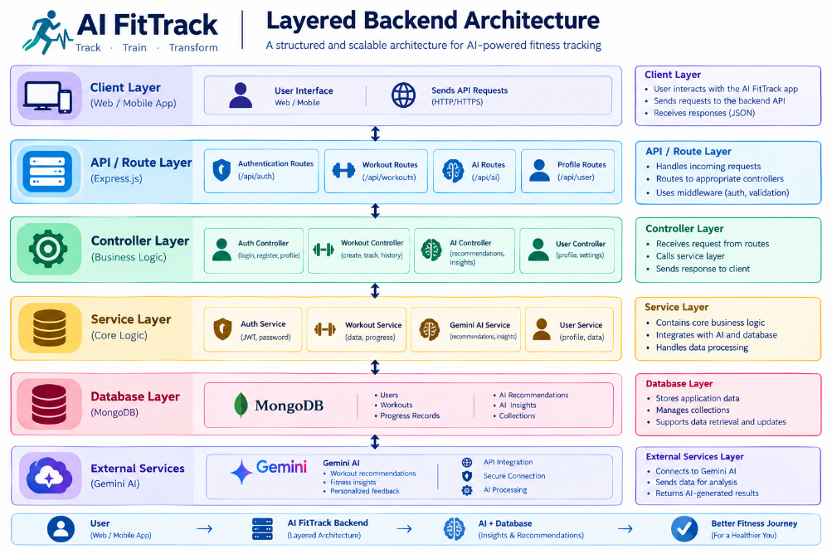
Main Layers
- Client/API Layer
- Backend Layer
- Authentication Layer
- Database Layer
- AI Layer
- Security Layer
AI FitTrack follows a layered backend architecture.
BACKEND AND DATABASE LAYERS
Backend Layer
The backend layer contains:
- Node.js
- Express.js
- REST APIs
- Controllers
- Routes
- Middleware
- Authentication
Backend Responsibilities
The backend receives requests from the client, validates the request, performs required operations, communicates with MongoDB or the AI service, and returns a JSON response.
Database Layer
MongoDB is used for persistent data storage.
The database stores user-related information required by the application.
Database Flow
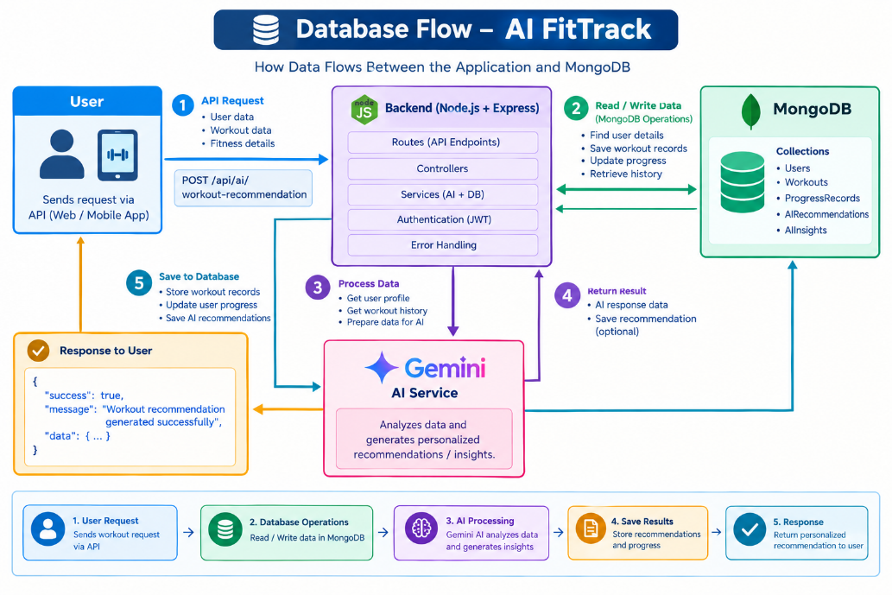 AI AND SECURITY LAYERS
AI Layer
The AI layer provides intelligent fitness functionality.
Main AI Functions
- Fitness Insights
- Workout Recommendations
- Natural-language AI responses
AI Processing Flow
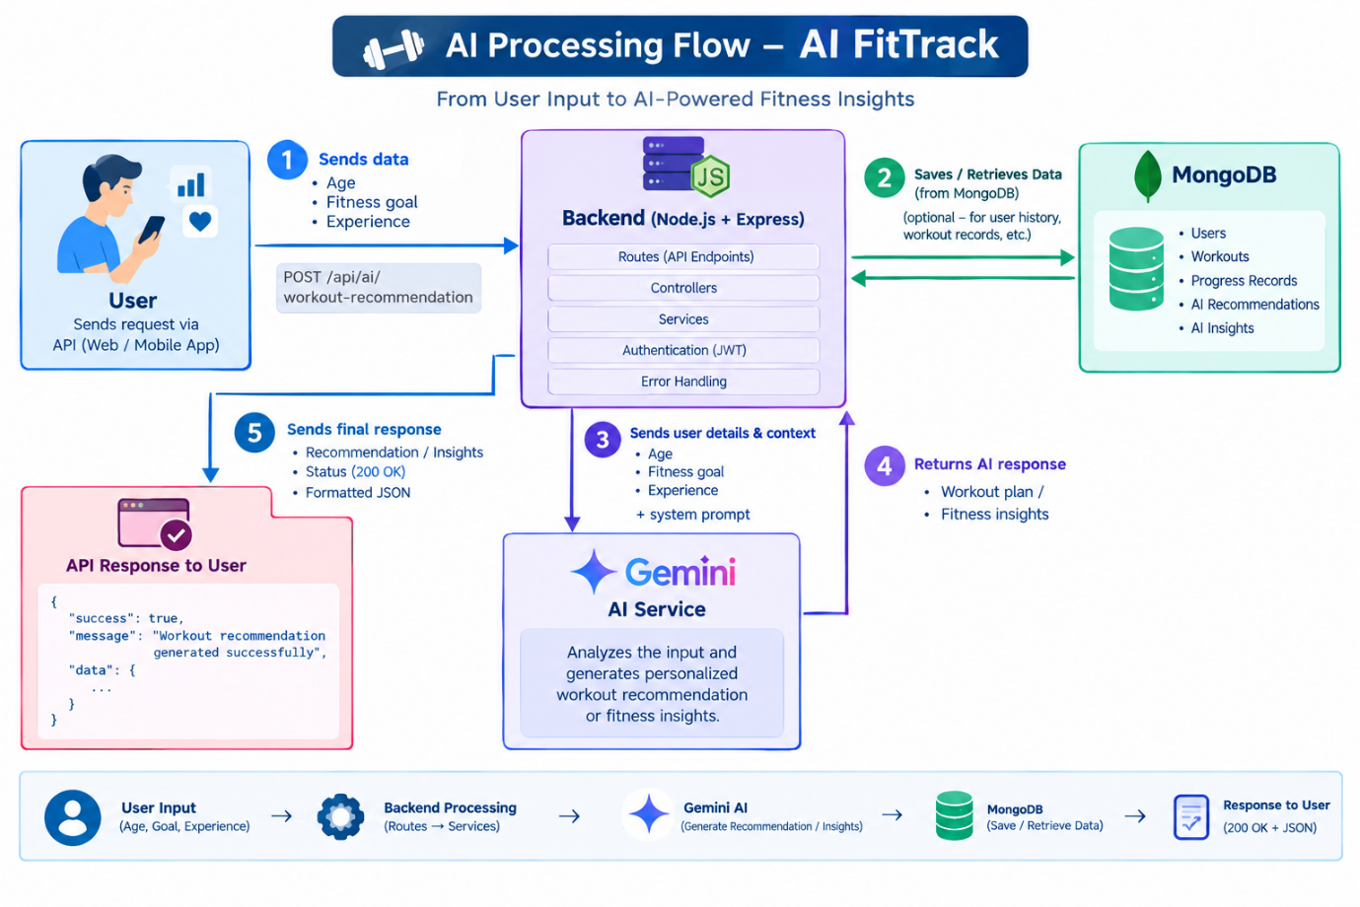
Security Layer
The application uses:
- JWT authentication
- Protected routes
- Bearer token authorization
- Environment variables
- Input validation
The protected profile endpoint was successfully tested using a Bearer token.
ER DIAGRAM
ER Diagram
ER Diagram –AI FitTrack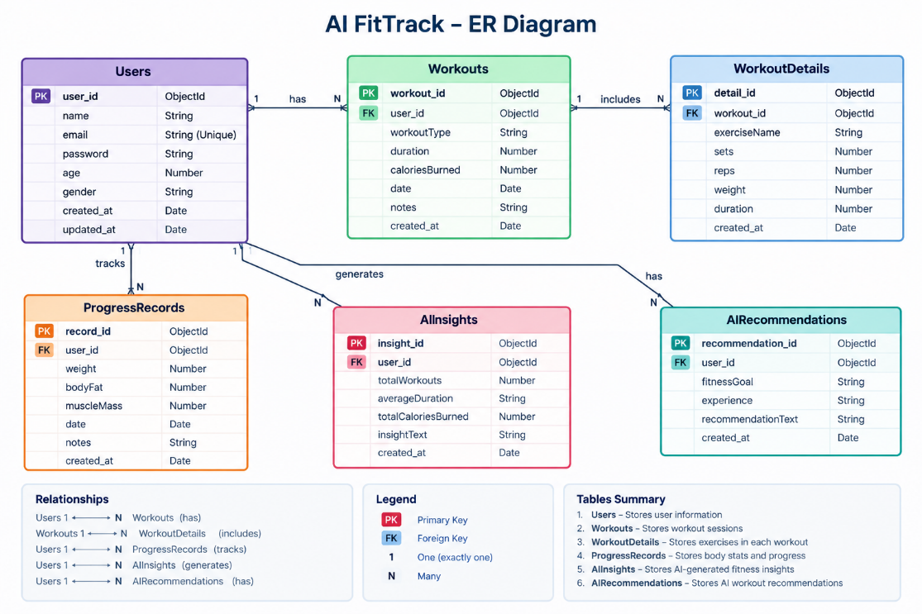 AI FitTrack
Important
Your current screenshots demonstrate the User/authentication functionality and AI request APIs. If your source code does not contain Documents, Embeddings, Chats, or ActivityLogs collections, those should not be shown as implemented database entities.
The mentor template itself lists those collections as examples for the larger AI-augmented architecture.
USER COLLECTION
User Collection
The User collection represents registered users of AI FitTrack.
User Fields
Field | Description
_id | Unique user identifier
Name | User's name
Email | Registered email address
password | Encrypted/secured password
Example User
{
"id": "6ab4687054671af9802dc894",
"name": "swapna",
"email": "user8@gmail.com"
}
The application uses the user's identity for authentication and protected resource access.
Future Extension
Fitness records could later be linked to the user through a userId field.

FEATURES
Core Backend Features
The current AI FitTrack backend demonstrates the following features:
1. User Registration
Users can create an account through the registration API.
2. User Login
Registered users can authenticate using their credentials.
3. JWT Authentication
A JWT token is generated for authenticated access.
4. Protected Routes
Protected routes require valid authentication.
5. Middleware
Middleware can be used to validate authentication and process requests.
6. MongoDB Connectivity
The backend connects to MongoDB for persistent data.
7. REST APIs
The backend provides RESTful endpoints.
The AI FitTrack backend provides RESTful APls for user authentication, protected resources, and AI-powered fitness services.
AI FEATURES
AI Features of AI FitTrack
1. AI Fitness Insights
Generates meaningful observations based on workout statistics.
2. AI Workout Recommendations
Generates workout guidance according to the user's age, goal, and experience.
3. Personalized Responses
The response changes according to the information provided by the user.
4. Natural Language Generation
The AI generates responses in understandable natural language.
5. AI Service Integration
The backend communicates with the AI service through a dedicated service module.
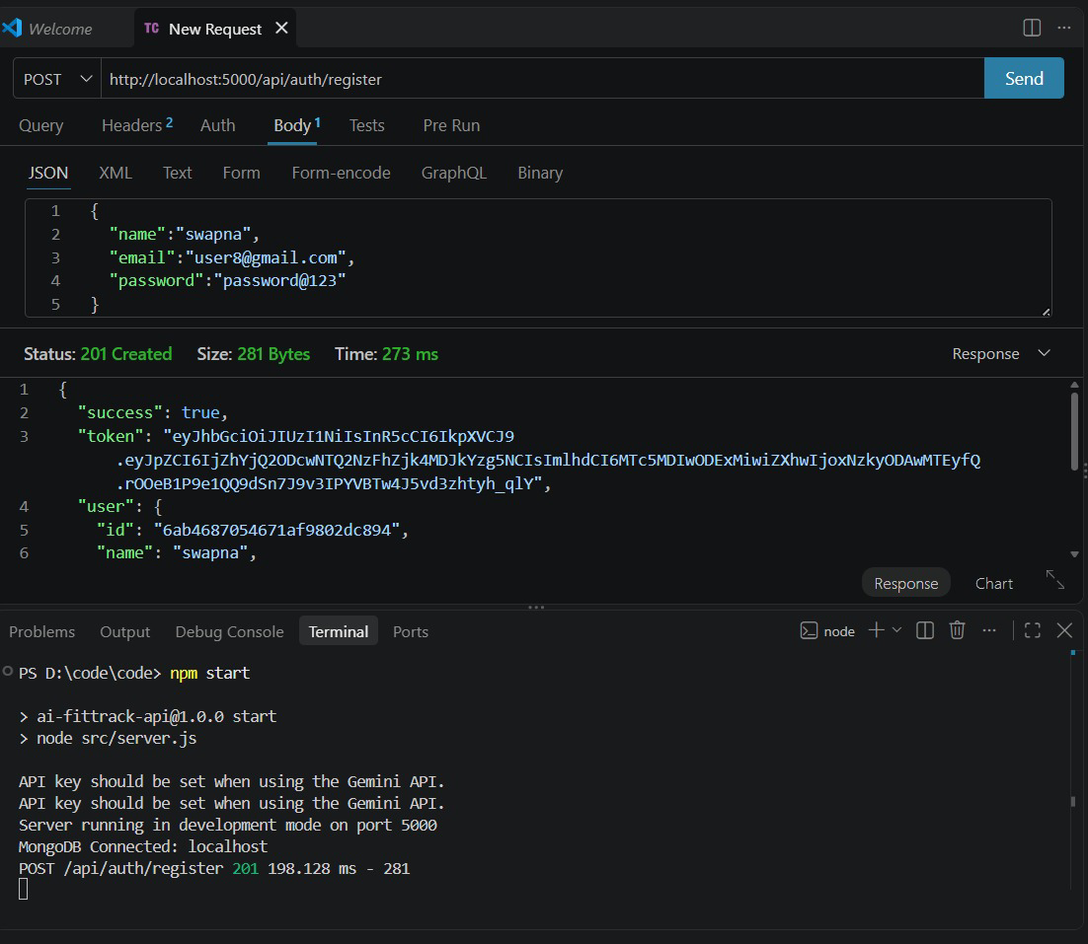

- The API registration output to look like this image. The registration request should return a 201 Created status, a success message, a JWT token, and the registered user details in the response.
- The backend should run on port 5000, and MongoDB should be connected successfully in VS Code."

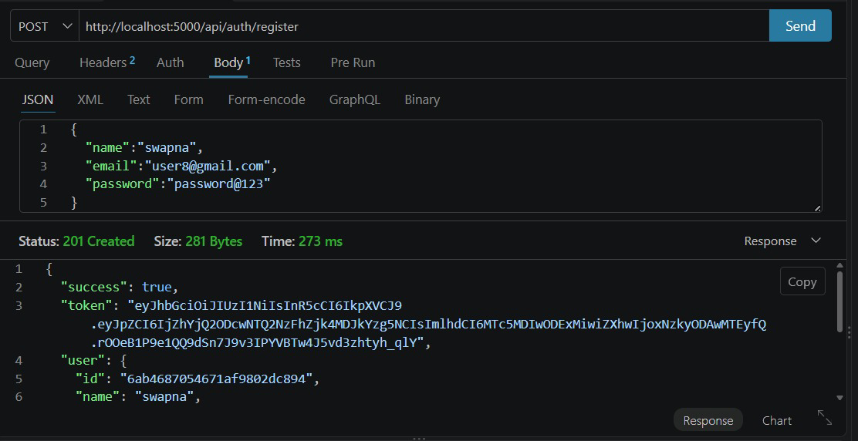
- The API registration response to look exactly like this image. It should display a 201 Created status, a success message (success: true), a JWT token, and registered user details such as the user ID and name.
- The API should work using the POST method at http://localhost:5000/api/auth/register."

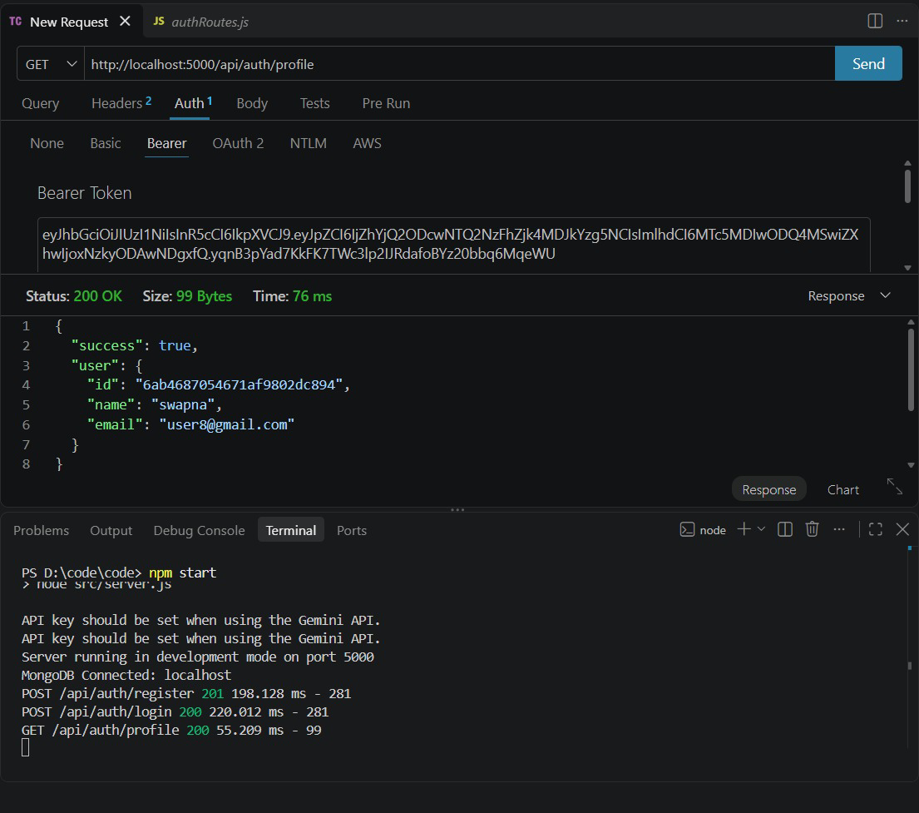

- The User Profile API that works like the attached image. The API should use the GET method at http://localhost:5000/api/auth/profile and authenticate the user using a Bearer Token (JWT).
- When the request is successful, it should return a 200 OK status with the user's ID, name, and email. The backend should run on port 5000, with MongoDB connected successfully.

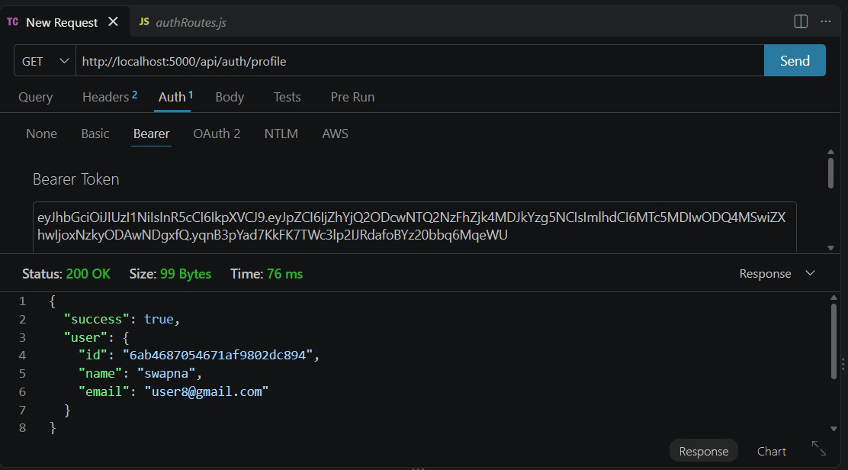
The Profile API retrieves the authenticated user's details using a JWT Bearer Token and returns a 200 OK response containing the user ID, name, and email.
Expected Response:
- Status: 200 OK
- Success: true
- User ID
- User Name
- User Email
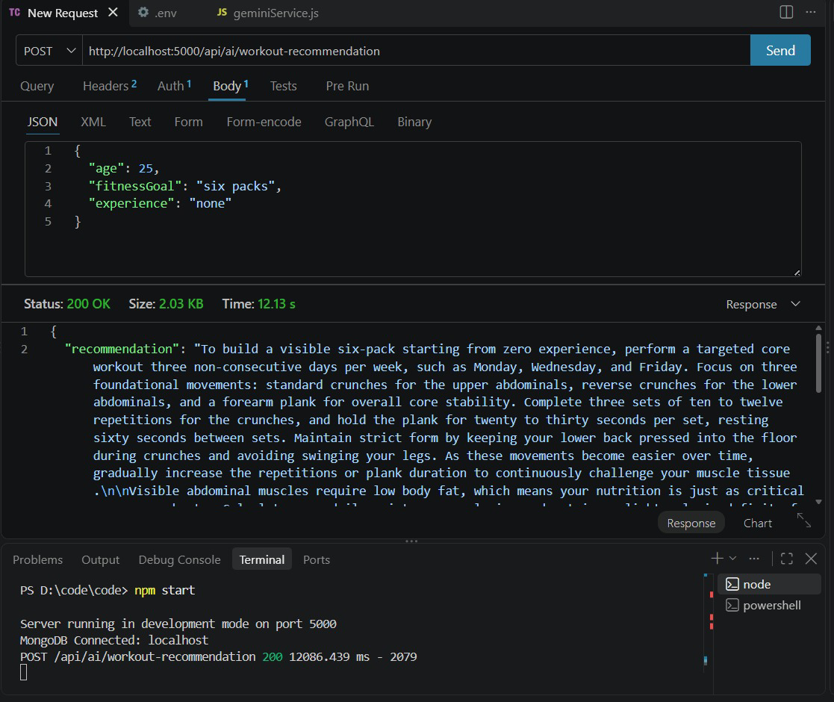
The AI Workout Recommendation API accepts the user's age, fitness goal, and experience, then uses Gemini AI to generate a personalized workout plan. The API returns a 200 OK response with the recommended workout.

Expected Response
- Method: POST
- Endpoint: /api/ai/workout-recommendation
- Status: 200 OK
- Response: Personalized workout recommendation
- AI Service: Gemini AI
- Database: MongoDB
- Server Port: 5000
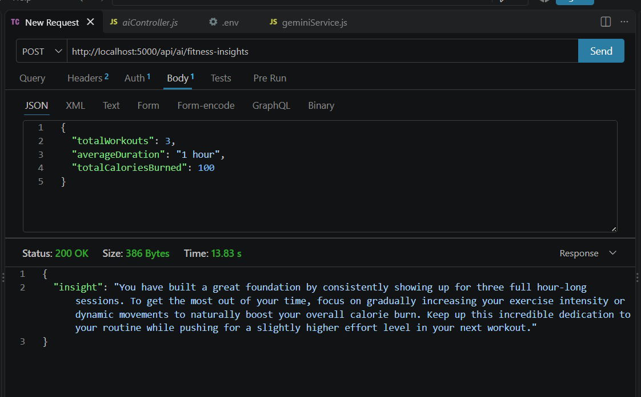

The AI Fitness Insights API analyzes the user's workout statistics, such as total workouts, average duration, and calories burned, and uses Gemini AI to generate personalized fitness feedback. It returns a 200 OK response with the fitness insight.

Expected Response
- Method: POST
- Endpoint: /api/ai/fitness-insights
- Status: 200 OK
- Response: Personalized fitness insight
- AI Service: Gemini AI
- Purpose: Analyze workout performance and provide feedback.
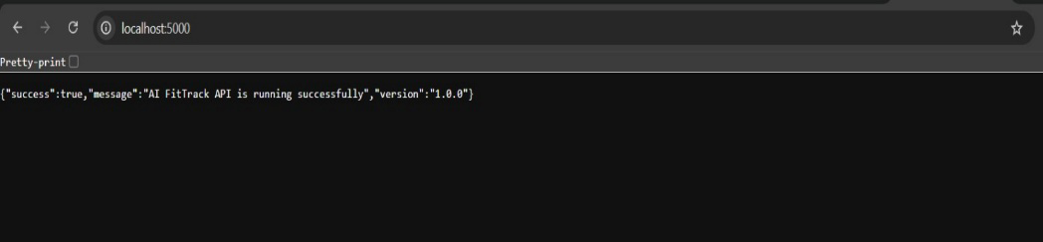
The Home API is used to verify whether the AI FitTack backend server is running successfully. It returns a success message and the API version .
URL: http://localhost:5000.
Expected Response
- Successful API response and APl version
- Version:1.0.0
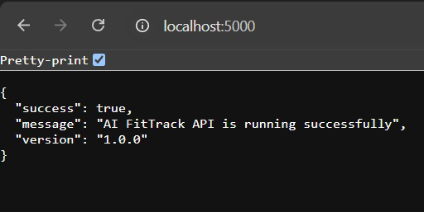

- The AI FitTrack API home page to display a properly formatted JSON response in the browser, as shown in the image.
- When the user opens http://localhost:5000, the API should return success: true, a message confirming that the API is running successfully, and the version 1.0.0. The response should be displayed in a readable, pretty-printed JSON format.

Drive link https://drive.google.com/drive/folders/1Wh2sVJXAP5EruTLp20Eh5f9jkHNvCQ_4

Github

Demo video
https://drive.google.com/file/d/11YLi2epor2HNbUb7JH3cIEDFtKDsPLJm/view?usp=drivesdk

Phase Document
1.https://drive.google.com/drive/folders/1L3JR80ws8JTClMyAfZSiyrFeMu1n0NcY

2.https://drive.google.com/drive/folders/1PhpKNKYorKceeBdc4dB5xmJ2MImQx0u6

3.https://drive.google.com/drive/folders/1ZpbP-sEkeAKJfGw_Y8J7ihNLpNSr-jqY

4.https://drive.google.com/drive/folders/1rz7rVMDrZj-zjceGHdCGUTXnJ4iR4NH_

5.https://drive.google.com/drive/folders/1FbAM8-TtSHovtFyyttnxFEIBs3lyM5zq

